**Project Design Phase-II**

**Data Flow Diagram & User Stories**

| Date | 26 June 2025 |
| --- | --- |
| Team ID | LTVIP2025TMID32174 |
| Project Name | EduTutor AI: Personalized Learning with Generative AI and LMS Integration |
| Maximum Marks | 4 Marks |

**Data Flow Diagrams:**

A Data Flow Diagram (DFD) is a traditional visual representation of the information flows within a system. A neat and clear DFD can depict the right amount of the system requirement graphically. It shows how data enters and leaves the system, what changes the information, and where data is stored.

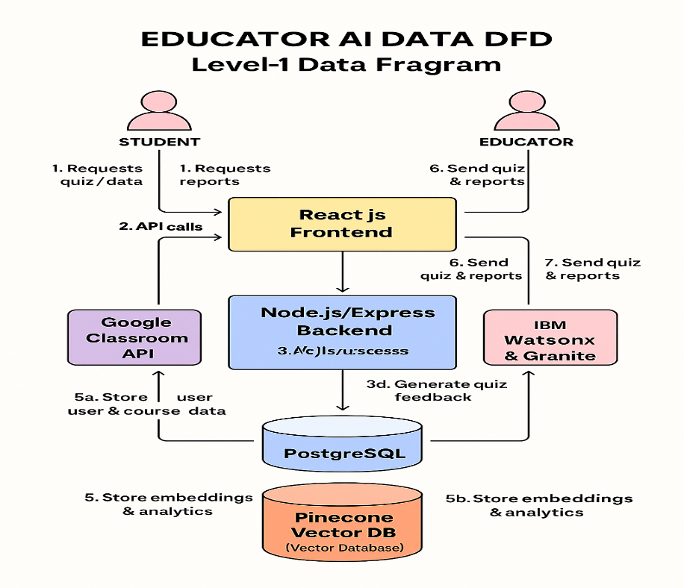

* Students/Educators send requests via the React.js frontend.
* Frontend routes requests to the Node.js/Express backend.
* Backend synchronizes rosters with Google Classroom and submits quiz-generation requests to AI services.
* AI services return dynamically generated questions and feedback.
* Backend persists profiles in PostgreSQL and analytical vectors in Pinecone.
* Backend returns quizzes, scores, and performance heatmaps to the frontend.
* Frontend renders results for students and educators.

**User Stories**

Use the below template to list all the user stories for the product.

| **User Type** | **Functional Requirement (Epic)** | **Story #** | **User Story / Task** | **Acceptance Criteria** | **Priority** | **Release** |
| --- | --- | --- | --- | --- | --- | --- |
| Student (Web) | login | USN-1 | As a student, I can register with email and password so that I can create my Edu Tutor AI account. | • I complete registration form • I receive a “Welcome”  • I land on my student dashboard | High | Sprint-1 |
| Student (Web) | Course Synchronization | USN-2 | As a student, I want to sync available subjects so I can choose a course for quiz. | • I authenticate with Google • My courses list appears in the dashboard | High | Sprint-1 |
| Student (Web) | User Confirmation | USN-3 | As a student, I receive a confirmation email after registration so that my account is verified. | • I get an email with a confirmation link • Clicking the link marks my account as “Verified” on UI | High | Sprint-1 |
| Student (Web) | Quiz & Assessment Management | USN-4 | As a student, I can take a diagnostic ts my proficiency level. | • I complete at least 6 questions • I see a summary report with strengths/weaknesses | High | Sprint-2 |
| Student (Web) | Quiz & Answer Submission | USN-5 | As a student, I can take an adaptive quiz so that questions adjust to my performance in real time. | • Each question adapts based on my previous answers • After submitting answers, the app returns a simulated score | High | Sprint-2 |
| Educator (Web) | LMS Integration & Analytics Reporting | USN-6 | As an educator, I can sync my class roster from Google Classroom so that Edu Tutor AI mirrors my current student list. | • I initiate sync • Student names/IDs import successfully • I see the updated roster in “My Classes” | High | Sprint-2 |
| Educator (Web) | LMS Integration & Analytics Reporting | USN-7 | As an educator, I can view a class performance heatmap so that I identify topic-level strengths and gaps. | • Dashboard heatmap loads within 2 s • Weakest three topics are highlighted per student | Medium | Sprint-3 |
| Educator (Web) | Quiz & Assessment Management | USN-8 | As an educator, I can generate a custom quiz on selected topics so that I target areas needing reinforcement. | • I select topics and question count • A quiz preview appears • I can export the quiz or launch it directly for my class | Medium | Sprint-3 |
| Admin (Web) | Track Multiple Users | USN-9 | As an admin, I want to see session data for each user | • In-memory dictionaries | Low | Sprint-4 |
| Developer(Web) | Error Handling | USN-10 | As a developer, I want the system to return clean error messages for invalid inputs | •Invalid inputs • Alerts trigger if latency > 2 s or error rate > 5 % | Medium | Sprint-4 |